TASK 1. Dennis Tikhomirov (Dzianis Tsikhamirau)

PART 1.

Create user

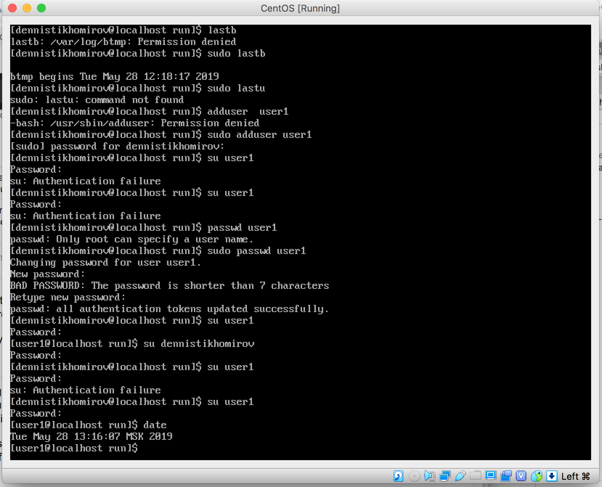

Age of system (I believe time of system installation equals time of creation directory root)

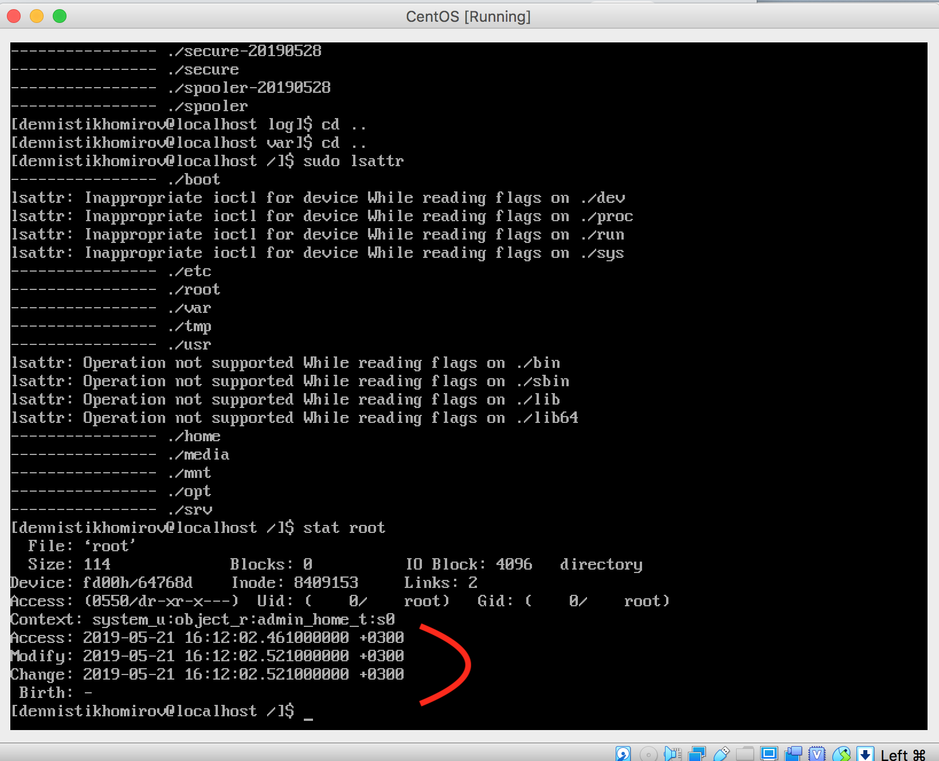

Last five logins

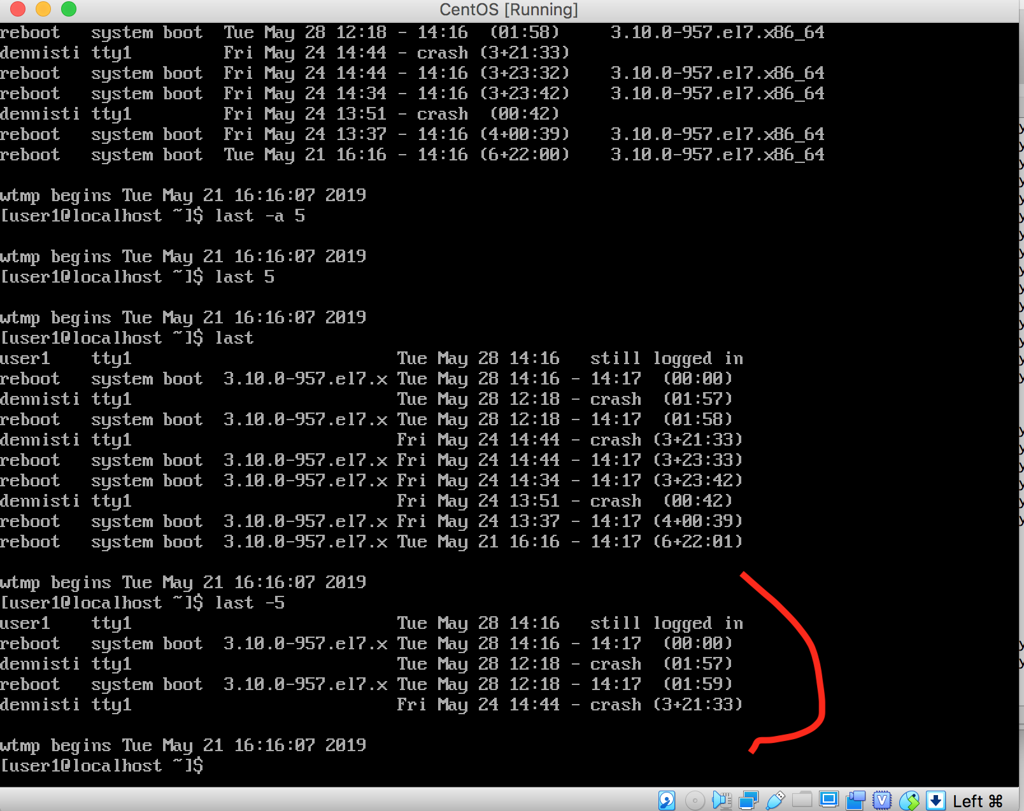

Failed login attempts

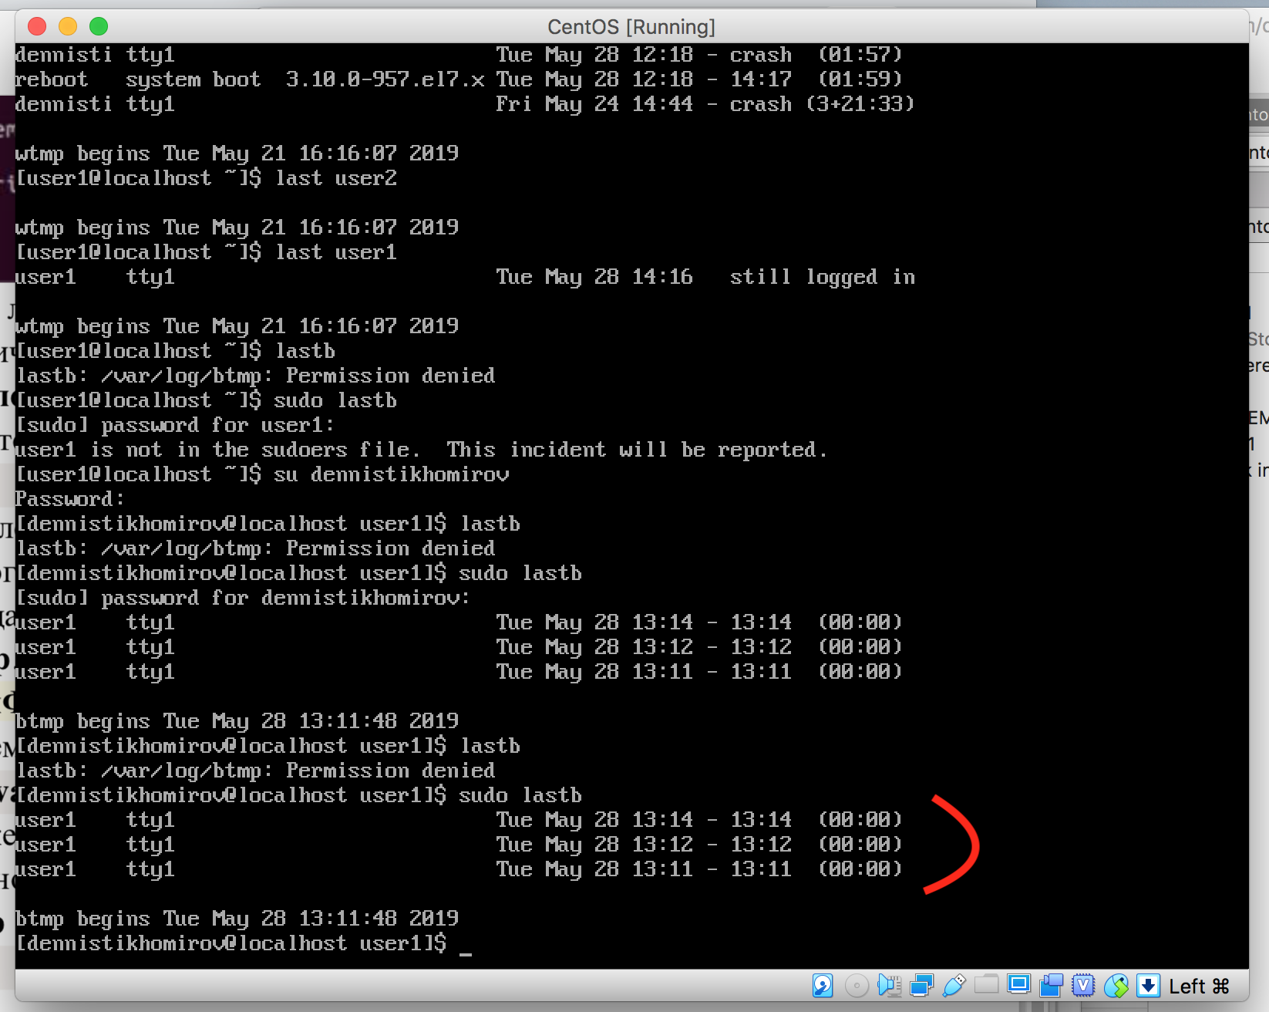

PART 2

1. Get to know the Linux commands. Execute top, free, ps commands with various options.

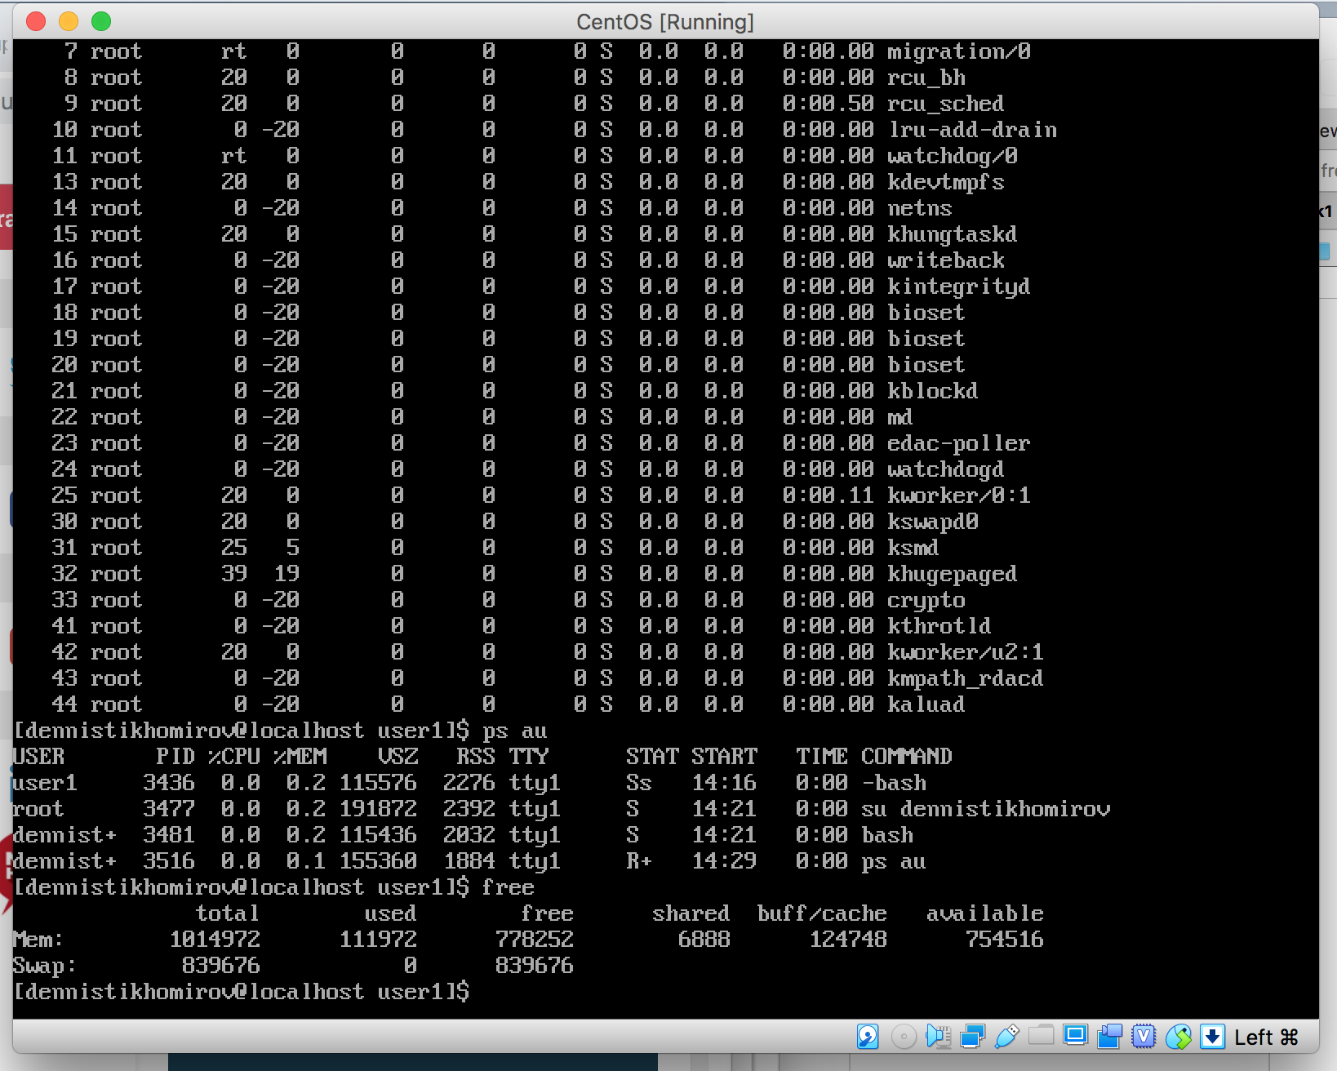

Create a symbolic link s_link to file5 in the lab1 directory

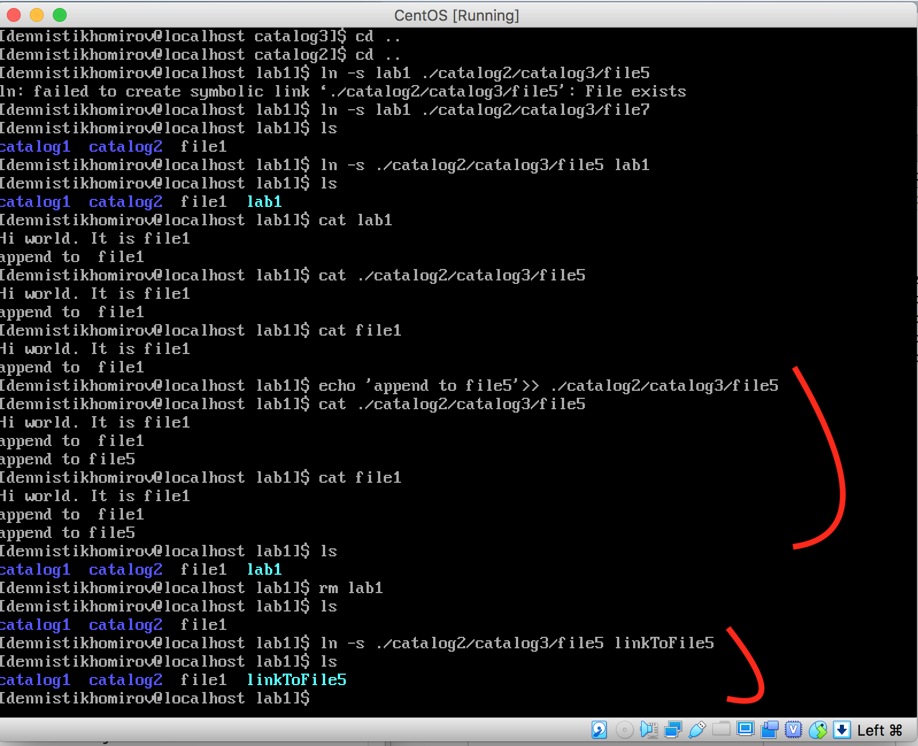

View structure created directories and view the contents of files.

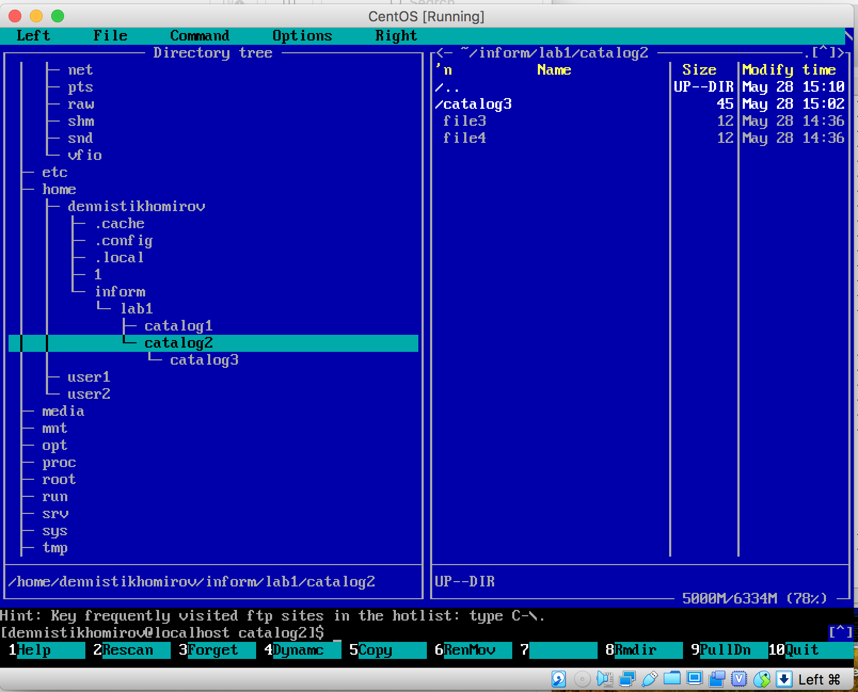

PART 3

Cinderella!

View structure created directories and view the contents of files.

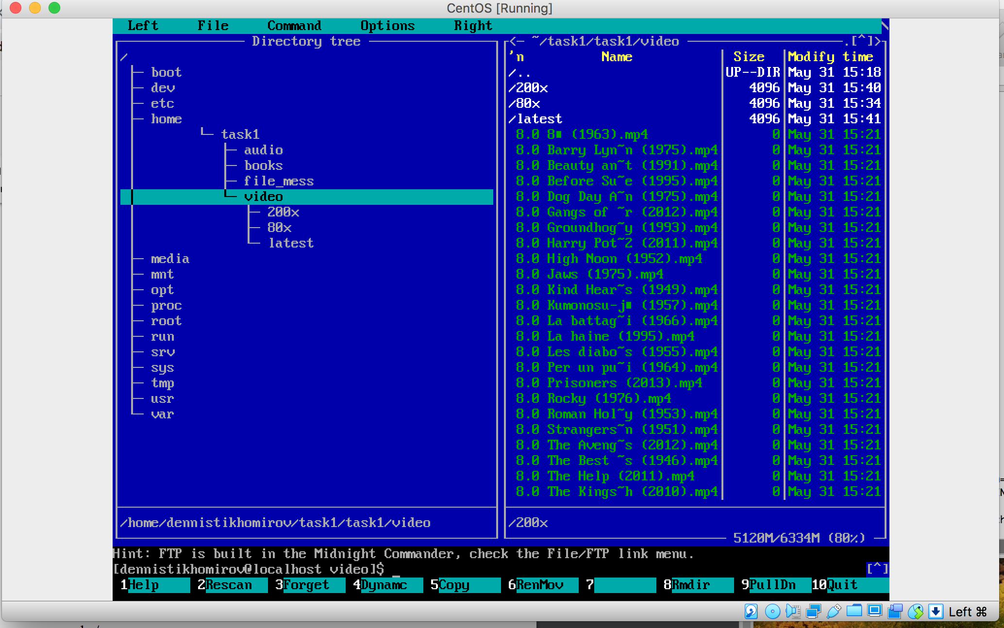

After files are moved to correct directories create archive task1.completed.tar.gz with all files. Send archive to lector.